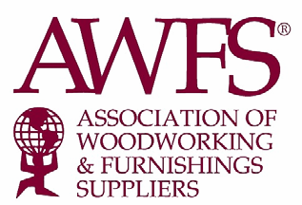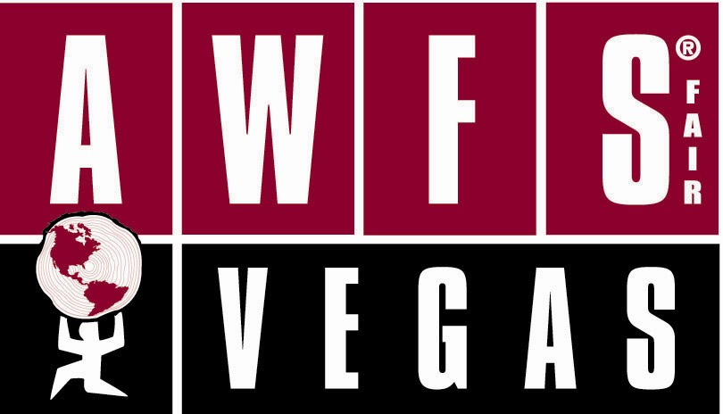

FOR IMMEDIATE RELEASE

New Booth Package Pricing Options Appealing to the
Already Strong Exhibitor List for the 2011 AWFS®Fair

CITY OF COMMERCE – Oct. 1, 2010 – Exhibitors contracting for the 2011 AWFS®Fair are finding good news – 2011 pricing for onsite labor and booth services have been frozen at the 2009 rates and AWFS is offering, for the first time, new booth square foot package pricing. The packages include material handling as well as options like essential furnishings, carpet, nightly vacuuming, electrical and rigging labor – all at one guaranteed price. Exhibitors also still have the option to order traditional Freeman services through the service kit – at 2009 prices!

These never before negotiated trade show booth package plans – the first in the industry – are being offered for AWFS®Fair in three booth sizes:
- 100 – 400 sq. ft. booths: a package price including material handling plus classic carpet, essential furnishings, nightly vacuuming, electrical & plumbing equipment and labor.
- 401 sq. ft. or larger packages including material handling, carpet, nightly vacuuming, rigging & electrical labor, plus one-time spotting of equipment (includes crane if necessary).
- 401 sq. ft. or larger package option 2 includes all options above minus carpet.

“AWFS and Freeman have worked very hard to come up with the square foot pricing packages which will allow exhibitors to efficiently plan and budget their booths,” explains Marguerite Hoffman, Vice President of Trade Shows, and AWFS. “The packages have been carefully thought out and cover all typical booth essentials.

The beauty of this program is that exhibitors have the ability to choose what is right for them. They can pick a square foot package, or order their services the traditional way – whichever is more cost effective.

“We have had an extremely positive response from exhibitors,” says Hoffman. This program is showing them that we are doing everything we can to increase their ROI.”

AWFS’s exhibit services partner, Freeman partnered with AWFS to present the options.

“For over the last 13 years we’ve partnered with the AWFS®Fair to make the exhibitor experience the most pleasant as possible,” said Dominick Esposito, Vice President, Freeman. “We have and will continue to strive to create and innovative solutions for all exhibitor needs, through economic packages, customer support and strategic planning. We look forward to the 2011 show, the new dynamic packages presented, and our continued vision toward successful exhibiting experiences.”

For more information on AWFS®Fair exhibits and the square foot packages, contact
Vince Burson at 323-838-9440 ext. 316 or vince@awfs.org (companies A – K) or
Don Donati at 383-838-9440 ext. 302 or dan@awfs.org (companies L – Z)

For more information on AWFS*Fair, go to http://awfsfair.org

About AWFS:
The Association of Woodworking & Furnishings Suppliers® (AWFS), founded in 1911, is a non-profit organization that wholly owns and produces the biennial AWFS®Fair. The largest trade association serving the entire home and commercial furnishings industry, AWFS has more than 400 members, including manufacturers and distributors of machinery, hardware, software, tooling, lumber, components, wood products and supplies for the woodworking industry including cabinet, furniture, millwork and custom woodworking products.

###

