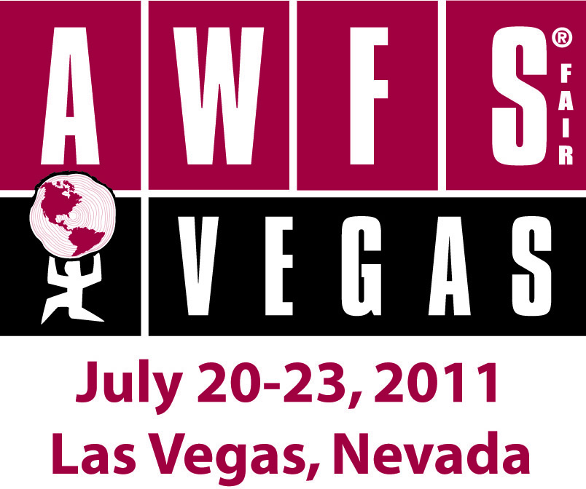

**Glossary of Terms**

Please refer to this helpful list of terms to help make your participation at AWFS Fair 2011 a success!

**Accessible Storage** Storage accessible to the exhibitor during show hours. Must be specifically ordered by the exhibitor.

**Advance Freight** Freight shipped in advance of move-in to the decorator warehouse for storage. Only fiber cases, palletized and crated freight can be shipped advance.

**Backwall** The rear wall of the booth configuration.

**Bill of Lading** An official shipping document indicating the origin, destination, contents, piece count and responsible parties for a particular shipment. All shipments in and out of the building must be accompanied by a bill of lading.

**Boom** A piece of heavy equipment used to access heights beyond a ladder's capability. Used for hanging banners and signs. Sometimes called a Boom Lift or by the brand names JLG or HyLift.

**Booth Height** The highest vertical point of the booth.

**Carpenters Union** Workers hired by the decorator to install and dismantle GEM/MIS, carpet, drape and signage.

**Carrier** A shipping company appointed by an exhibitor.

**Clean Floor Policy** A policy that requires ALL crates be removed from the floor at a specific time and date during move-in, whether the crates are empty or not.

**Crated** Freight shipped in wooden containers or crates. Crated shipments can be shipped in advance to the decorator warehouse.

**Cubic Content** The dimensions of content defined in a cubic measurement. i.e. Cubic feet.

**CWT** Hundredweight, A measurement of weight equal to 100 pounds. This measurement is used to determine materially handling fees. E.g. The shipment weighed 5670 pounds or 57 cwt.

**Decorator** The company contracted by Operations to provide labor, in-bound and out-bound material handling, rigging, booth cleaning and decoration to the show as designated by Show Management. The Freeman Companies is the decorator for the AWFS Fair.

**Double Time** Rate of labor times two or doubled. Normally enforced on holidays.

**Drayage** (also called Material Handling Fee) Costs incurred by the exhibitor for material handling by the decorator. Drayage covers unloading and delivering the shipment to the booth, storing empty crates during the show, returning empty crates to the exhibit space at show close, and load the shipment onto the exhibitor’s carrier. Drayage is calculated by a rate predetermined by the decorator and based on total weight of freight received. The rate may vary depending on whether the shipment is sent directly to show site or sent to the advance warehouse and other factors such as how the shipment is packed. Any shipment handled by the decorator will be charged a minimum of 300 pounds.

**Exhibitor Appointed Contractor** (EAC) A contractor appointed by the exhibitor to provide services such as booth installation and booth dismantling, floral, photography, security, audiovisual, and computer rental. Some venues have the exclusive right to connectivity, electrical and telecom services. Please consult Show Management regarding any questions.

**Empties** The crates, cartons, cases and packaging that exhibitors use to ship their freight. Exhibitors are required to designate which empties they want returned to them by attaching “Empty” stickers provided by the Decorator. These empties are returned at the close of the show after the aisle carpet has been removed. Exhibitors failing to label their empties or failing to provide their booth number on the label are likely to have their empties discarded.

**Exhibit House** A company that is hired by the exhibitor to design or customize their booth.

**Exhibitor Service Center** The area at the show site where exhibitors inquire about, order and pay for their services ordered. The Service Center is staffed with representatives from official vendors including the decorator, lead retrieval, electrical, and shipping.

**Fabric** Fabric covered panels used in prepackaged or prefabricated booths. (This fabric is very similar in look and texture to the material used in office cubes.)

**Fiber Case** A plastic case ranging in a variety of sizes used to transport booth freight. They are often used to hold displays for 10' x 10' and 10' x 20' booths. Exhibitors are allowed to hand-carry a fiber case through the front doors of the building.

**Fire Marshal** A person assigned to each facility to ensure that the event production complies with the fire and safety regulations of the building. Examples of safety regulations: Designated aisle widths, allowable structures in concourse, corridors and hallways, fire alarm/sprinkler clearance, maximum occupancy and so on.

**Forced Freight** Freight left behind at the show site by the exhibitor without a bill of lading (proper shipping instructions) or freight not picked-up by the exhibitor-designated shipper. At the time designated in advance by the decorator, all freight not identified by a bill of lading or not picked-up by an appropriate shipping company will be “forced”—shipped by the decorator at the exhibitor's expense.

**GEM/MIS** A prepackaged, custom exhibit offered by the decorator for rental. These booths may vary in sizes and decor options.

**Hanging Sign** A sign that hangs from the ceiling over an island booth of 20' x 20' or larger. The signs can hang no higher than the height specified in the Exhibitor Service Manual. This height is typically determined by building constraints. Note: rigging charges will include the cost of labor and the required boom lift for both the installation and the removal of the hanging sign.

**HAZMAT** Hazardous material management. The disposal and clean up of hazardous materials or products.

**Header** Flexible, plastic sign attached to and located along the front of a custom, prepackaged or prefabricated booth.

**Install and Dismantle** (I&D) Often EACs (Exhibitor Appointed Contractors), are appointed by the exhibitor to install and dismantle their display, as opposed to using decorator labor from Freeman.

**IP Address** An address or number assigned to a computer that is designated to a network.

**Integrated Services Digital Network** (ISDN) A type of phone line that performs bridging, routing and support of analog devices such as phones, faxes or networks. Often an ISDN line will be necessary for live radio broadcasts done at show site.

**Island Booth** A booth that has no adjacent exhibiting booths and aisles on all four sides. These booths are generally 20' x 20' or larger.

**Kiosk** A structure of one or more sides used for encasing signage of one meter wide by 8 feet high.

**Labor** A crew of people designated by the decorator to receive, move and deliver freight, to install carpet, and to build and dismantle displays throughout the show. Labor can also include electrical labor and rigging labor.

**Lead Retrieval** An electronic system used by exhibitors for retrieving attendee mailing information and demographics from the magnetic strip on the back of the badge. These systems are designed to provide exhibitors with either a hard copy or electronic form of all their leads gathered and are essential for the exhibitor's post-show marketing.

**Linear Booth** (Inline Booth) A booth positioned in a line of other booths. If the booth exists in an area that is not on the perimeter or outer edge of the floor, they will have other booths surrounding on the backside.

**Look and Feel** (Also known as event branding.) Look and Feel is the decoration of the show, produced by Show Management. Look and Feel includes everything from the color of the carpet and drape on the exhibit floor, the official show signage, the color of build-outs, and the design of registration counters, branding used for signage, and so on.

**Marshaling Yard** A parking lot provided by the convention center to stage inbound and outbound trucks prior to unloading and offloading of freight at the convention center. The Marshaling Yard may be located off the immediate premises of the show site. Once at the yard, the trucks weigh-in and are issued a weight-slip which specifies the weight of the freight to be applied to the drayage by the decorator. When a target-freight plan is in use, trucks will only be allowed to unload during their scheduled time and date, which they obtain on a first-come, first-served basis unless otherwise authorized by Show Management. On non-target freight events, trucks are received on a first-come, first-served basis unless otherwise authorized by Show Management.

**Material Handling** Material handling is the process of unloading exhibitor freight and delivering the freight to the booth, storing empty crates, and then loading exhibitor freight at the close of the show. Freeman is responsible for handling all material delivered to the show and charges a fee for material handling. An exhibitor may carry in his own freight only if the freight can be hand carried and brought in through the show entrance.

**No Freight Aisles** Aisles in which the building has mandated to be clear and free of any obstructions due to fire and safety evacuation purposes. These aisles are nonnegotiable in terms of booth and freight placement.

**Off Target Charges** Extra charges added to material handling costs for shipments arriving after Target Move-in Time, which is specified on Target Move-in maps.

**Overtime (OT)** Time and a half of the specified hourly labor charge. In cases of holidays, double time, or twice the normal labor rate.

**Palletized Freight** that is placed on a pallet or skid which allows it to be moved via forklift. Palletized freight is recommended to be shrink-wrapped or wrapped tightly in a plastic film material similar to Saran Wrap.

**Peninsula Booth** A booth abutting, (against the backwall), of another booth that is open on three sides. Mandatory backwall height cannot exceed 16 ft.

**Perimeter Booth** A booth existing along the perimeter or outer booth row on the floor.

**Porter Service** A service for exhibitors to get product unloaded from their privately owned vehicles and delivered to their booth.

**Placard** A sign specific to 8" x 11" in dimension.

**Privately Owned Vehicles** (POV) Privately owned vehicles used to deliver or pick-up freight.

**Prepackaged/Prefabricated Booth** Booth designated by Show Management with pre-selected options. Exhibitors may or may not have options in regard to color/material and furnishings depending on the exhibit. Please consult Show Management in regard to any questions.

**Rigging** A labor service required by the decorator for hanging signs, banners and accessing heights.

**Right to Work** Some states such as Nevada, are "right to work" states. This means that exhibitors are allowed to conduct their own install and dismantle without the requirement of union labor.

**Shrink-wrap** A plastic film, usually clear and similar to Saran Wrap, used to hold cartons together on a pallet.

**Show Card** A 22"w x 28"h sign.

**Side Wall** The wall or drape along the side of the booth.

**Signage** All signs throughout the show including headers, kiosks, banners and directional signs.

**Skidded Freight** placed on a pallet or skid which allows it to be moved via forklift. It is recommended that skidded freight be “shrink-wrapped”.

**Straight Time** Standard labor without any overtime or double-time.

**Surcharge** An additional sum added to the usual amount or charge. This charge is usually applied in cases where exhibitors have failed to ship their freight for arrival on the designated target date or time.

**Target Time** The decorator appointed time and date in which an exhibitor's freight should be received at show site. This date and time is based on the size and location of a booth in consideration of the booth's proximity to freight doors and mandatory aisles.

**Teamsters Union** The union that provides labor for the handling of freight.

**Uncrated** Freight that is not shipped in wooden containers or crates.